(Approx. 1349 words)

Meet the many members of the Arduino family
By Dick Maybach, Member, Brookdale Computer Users’ Group, NJ
August 2017 issue, BUG Bytes
www.bcug.com
n2nd (at) att.net

The Arduino is a controller rather than a complete computer like the Raspberry Pi (which I’ll discuss next month); it’s much simpler and getting started with it is far easier. It has no operating system and runs only one program at a time, which starts when the unit is powered and runs until power is removed.

To start you need only to connect it to a PC’s USB port, which provides power, control, and information exchange. As a controller, it’s strength lies in its ability to control and to collect data from external devices. Thus, using an Arduino invariably involves external circuits and devices. These can be as simple as switches and LEDs or as complex as robots and drones.

There are several Arduino models. You should probably begin with the Uno, the most used and most robust in the family. The Mega and Zero have higher performance and more input/output termArduino-1inals for more complex projects. The Gemma and the Lily pads are smaller and designed to be incorporated into garments. The MKR1000 includes WIFI and is designed to Internet of Things (IoT) projects. There are also dozens of expansion boards, called shields, to add functions to all the models.

The Arduino provides a very easy way to get started with computer hardware technology and software. You work in your native computer environment – Windows, macOS, or Linux.

The Arduino comes complete; you have only to connect it to your PC with a USB cable, which provides both communication and power. The supporting software, the Arduino Integrated Development Environment (IDE), is free; just download and run it.

The first experiment (a “Hello World” program) requires nothing except the Arduino board, a USB cable, and the IDE. You can have it running in just a few minutes.

To go further, you will need some basic electronic parts (switches, LEDs, and sensors), a prototyping board, and some jumpers. Many vendors sell inexpensive kits with these parts and instructions for experiments using them.

The components plug directly into the prototyping board, where the Jumpers connect them to each other and to the Arduino ports. No soldering is needed.

At some point, you may wish to add expansion boards (called shields in the Arduino community), and some of these do require soldering. This is not difficult, as learning kits with the tools, practice material, and instruction are available, and it’s a skill you will find useful if you progress beyond a few basic experiments.

Figure 1 shows a naked Arduino (that is one without an attached shield) connected to a PC and running the program of Figure 2.
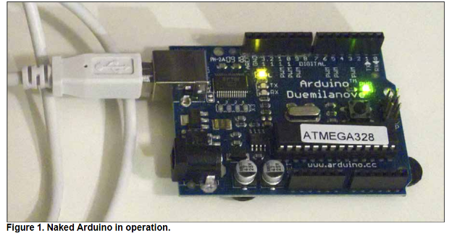

The green LED is a power indicator and the yellowish LED is the one controlled by the program. You can also see the black terminal strips that contain the analog and digital input and output pins to which the shields connect. Once you’ve loaded the program, you can disconnect the board from your PC.

The program will then start as soon as you power the board, either through the USB port as shown or the black power connector at the bottom-left.
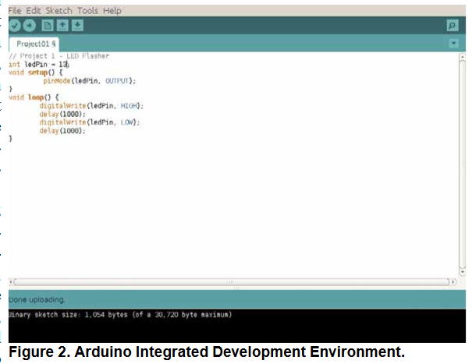

Figure 2 shows the Arduino IDE window on a PC; it’s available for Windows, macOS, and Linux. It also shows the Arduino version of “Hello world,” the first program you write when learning a new language. Arduino’s native language is a simplified form of C++, and in this program, it just turns on an LED for one second, off for one second, and repeats forever. The first line is a comment, and the next three set up the hardware so that pin 13, which is connected to the LED, will be controlled as a digital output.

The section beginning with “void loop ()” is the program. It moves the pin-13 Voltage high, waits 1000 milliseconds, moves it low, waits 1000 milliseconds, and repeats. Although it looks quite simple, this exercise is far from trivial, as it shows that your naked Arduino is working properly, that its IDE is installed and configured correctly,
and that you can program it. If your next project misbehaves, you have only to
check its code to find the error.

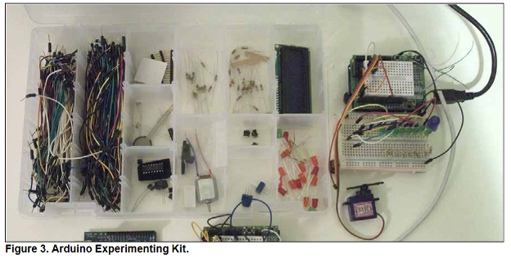
Figure 3 shows the Arduino kit I’ve assembled over several years. At bottom-left is a
naked Arduino; this is a complete controller with its one LED and one push-button, with which you can run very simple experiments. At bottom-center is an Arduino with a small prototype board (called a “shield” in Arduino-speak). You plug components and wires into the white board to create simple circuits and connect them to the controller. The compartmented case holds my collection of wires and components (LEDs, switches, sensors, a motor, a servo, and a LCD display. Finally, on the right is another Arduino with a prototype shield and a larger prototype board for more complex circuits.

Arduino and a white prototype boards make it easy to get started in electronics. The components don’t require soldering, but just plug into the board. Everything is controlled by the processor, which you can monitor using the IDE. The input devices (e.g., switches and light and temperature sensors) and output devices (e.g., LEDs and motors) are visually observable without instruments. (Although you may wish to purchase a cheap multi-meter to check Voltages and resistor values, as modern resistors are tiny and their values indicated by even tinier color bands.)

Arduino’s strength lies in its relative simplicity. You work entirely from your own PC, which means you are in a familiar environment and can concentrate on the programming and the hardware. Most people will start with Arduino, a prototype shield, and a parts kit, available from several suppliers. Typically, the circuits in
published projects are shown pictorially, as in Figure 4, rather than as schematics. As a result, you can assemble them without knowing how to read schematic diagrams.
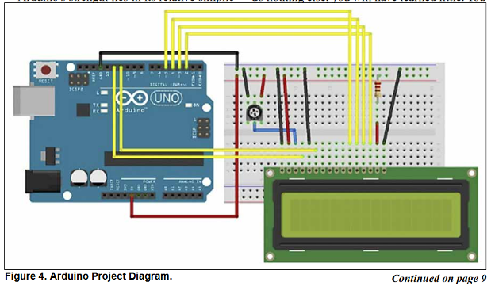
Most project descriptions will have a paint-by-the-numbers nature. You connect components and jumpers according to the pictorial, paste the code into the IDE, and see what it does. If you do nothing else, you will have learned little. You can learn much more by experimenting with the code and the circuit after you have it working. For
example, if the project is a blinking LED, change the code to make it blink faster or slower or with different on and off times.

Because most Arduino projects include circuitry, you will be learning about electronics as you progress. The prototype boards mean you can assemble the circuits without soldering and can make changes rapidly. Since most of the complexity is handled by software, the circuits are usually quite simple, and this is typical of modern electronics. Open the case of a modern device and compare it to one made years ago, and you will be struck by how much simpler the modern one is, despite its far more complex functions. This means that young people working with Arduinos are preparing themselves for successful careers in electronics.

The Arduino home Website, http://www.arduino.cc/, is where you go to download the IDE, learn about the different versions of the processor, obtain tutorials, and purchase devices and kits.

You will see two product lines, Arduino and Genuino. The development team split and formed two different companies. They have recently resolved their disagreement, and the two product lines will most likely merge. (There are also several clones, but I prefer to purchase Arduino products to support its continued development.)

Many electronics vendors supply Arduino products, accessories, kits, and tutorial material. Three prominent ones are Ad fruit, http://www.adafruit.com/, Spark Fun, http://www.sparkfun.com/, and Element 14, http://www.element14.com/community/groups/arduino. A search for “Arduino” will show you many more. If you prefer to see before you buy, check your local RadioShack, although not all stores will have a good inventory. When you tire of watching blinking LEDs, check the Instructables Website, http://www.instructables.com/id/Ardui-
no-Projects/, for more complex projects. Arduino is popular enough that your local Barnes & Noble probably has several books on it, making getting started easy.

